Mylan WTT Championships (Continued)
By: Andre Walls

Using a green ball instead of the yellow ball, which is used worldwide, makes for longer points and neutralizes power for the kids to enjoy the game. Playing with a faster paced ball can lead to fewer rallies and balls jumping over the juniors’ head. At the end of the day it’s about making tennis a fun sport for all kids no matter their gender and being able to play together as one big team.
Junior players pose for a photo before matches began Saturday afternoon
As tennis can be such an individual sport that causes selfishness, the Green Dot Ball Championships hopes to inspire kids to learn about the ethics of teamwork and learning to cooperate with others. “It’s not just me, me, me,” Mast said. “Learn to be a leader, how to be a support role, [and] learn to get along,” are the biggest lessons a young player can get out of the experience Mast felt.
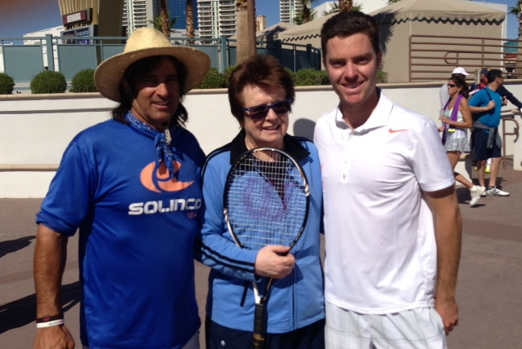
This is the first year of the WTT junior championships and with an overwhelming outcome, the future looks promising for the 14s and under team tournament. With 12 teams joining the roster with no problems of recruitment, the league expects to span out across the country in hopes of a bigger event in the years to come.
Event co-hosts Billy DeRango and Trent Alenik with Billie Jean King on Saturday
In honor of King’s 70 birthday weekend, 200 of her closest friends flew to Las Vegas to celebrate the wonderful person she is.
In a morning filled with tennis, King and others held a clinic at the LVH Hotel and Resort, hosted by Anne Guerrant, Trent Alenik, and Billy DeRango.
“She has a way of touching the souls of those she comes in contact with and you could see by the smiles of those around her,” Alenik said.
After an eventful day of tennis, King and the rest of her entourage attended the Million Dollar Piano show sang by Sir Elton John. In a concert where John performed several awards winning songs, it led to a standing ovation from King and the rest of the audience.
At King’s private party, held at the Caesar’s Pool, numerous stars attended such as Andre Agassi, Steffi Graff, Bud Collins, Tracy Austin, Lindsay Davenport, Mark Eins, and many other famous faces to support one of the most influential leaders in the sport’s history.

