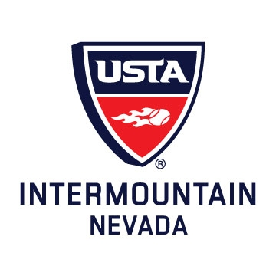
USTA Adult 40 & Over National Championships: October 11-13, 2013, Indian Wells, CA
Women's 3.5 Red Rock CC Team:
Captain Mariko Larssen, Patricia Freeman, June Seid, Jenny Penesa, Merle Lok, Shari Paterson, Arlene Babbitt, Jeanne Plantiff, Claudia Sleet, Phonthip Garringer, Kelly Griffin,, Maria Quintana, Anette Whiteside, Jerri Perfect
Men's 3.5 DragonRidge CC Team:
Captain Charles Day, Robert Peck, Patrick Hicks, Nicolas Guttman, John Brugman, Anthony Taeubel, Heath Wills, Lance Allgower, Matthew Mills, Larry Ladd, Stuart Deutsch, William Eisinger

USTA Adult 40 & Over National Championships: October 18-20, 2013, Indian Wells, CA
Men's 4.0 Desert Palm Team:
Captain Al Aubry, Richard Ward, Greg Farina, Majid Mirzazadeh, David Rennick, Tony Tijerina, Jeremy Christensen, Sonny Ho, David Doherty, Cory Trotter, Alejandro Garcia, David Cain, Rene Mauban, Willie Mann, Victor Cardoza, Rudiger Merz

USTA Adult 18 & Over National Championships: October 25-27, 2013, Tucson, AZ
Women's 3.5 Red Rock CC Team:
Captain Mariko Larsen, Patricia Freeman, June Seid, Shari Patterson, Arlene Babbitt, Jeanne Plantiff, Claudia Sleet, Phonthip Garringer, Anette Whiteside, Jerri Perfect, Gyongsuk Kim, Kimberly Lowe, Hillary Hall

