Living With Passion
In June Redfoo decided to chase after his dream to hopefully one day play in the US Open where he was given the opportunity to play the US Open sectional qualifying tournament. This dream came to an end at the hands of Fresno City College’s Scott Gray with a 6-1, 6-2 win over Gordy. Although he was not victorious, the loss did not stop Gordy from continuing to train every day for four hours, as he does with coach Adam Kennedy, and pursue his passion, which is the message he hopes to send out to the rest of the world.
“He’s got such a creative mind and his creativity is immediate,” Leiviska said. Whether it is DJing, playing tennis, or picking up surfing lessons, Redfoo feels that the importance of staying busy and learning new things is a key to happiness. “As long as you’re passionate about something go for it,” Leiviska later explained. At 38-years-old Redfoo intends to defy the odds and compete at a high level despite his age or loss of practice throughout the years.
Redfoo is the current sponsor of the Party Rock Open held at Stacy Darling Center. With his unique flair, he hopes to bring more attention and popularity to the game of tennis. From the bright pink banners to the zebra print pants, the tournament certainly does not lack originality.
In the minds of this mother-son relationship, anything is possible. Passion gives you motivation, positivity keeps you going, and learning is infinite. “Get out there and try everything,” Leiviska said. “Just be passionate and that’s the real win.”
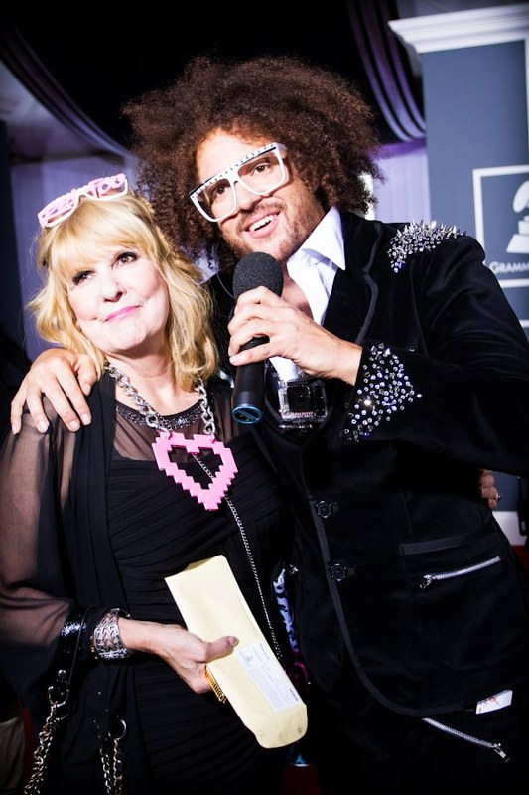

Nancy Leiviska and son Redfood

