Semifinal Birth for Hibi; Oudin Up Next
By: Andre Walls

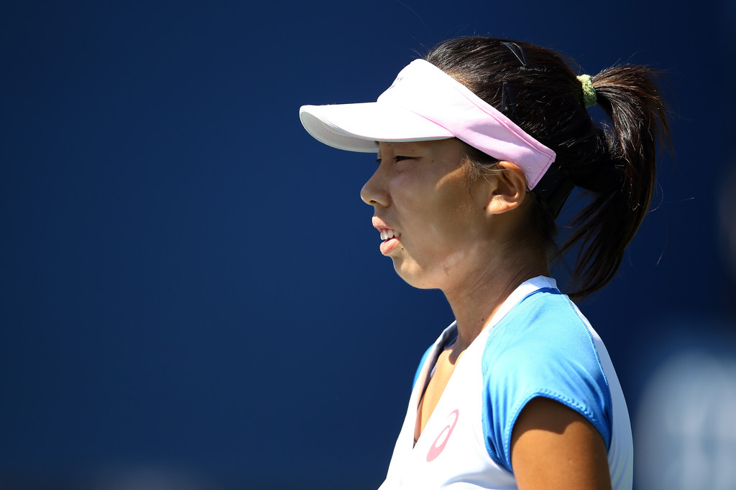
Mayo Hibi of Japan ranked 228 in the world
Up next for Mayo will be 2009 US Open quarterfinalist Melanie Oudin who routed her South African opponent, Chanel Simmonds, 6-2, 6-2. The two have never played on the circuit before, but are expected to take part in Saturday’s night match at 6.
With only one other American in the tournament, Coco Vandeweghe will try and keep the chase alive when she takes on Anna Tatishvili of Georgia.

