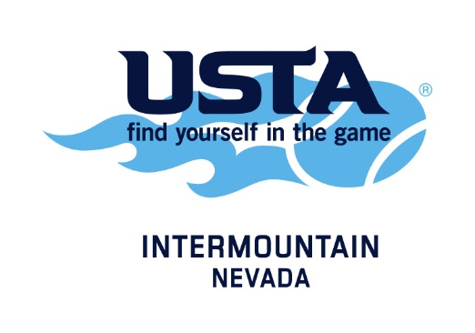
2016-17 Adult award winners

George MacCall
Lifetime Achievement Award
George Davidson

Community Leadership Award
Mayor Carolyn Goodman

Organization of the Year
Lake Las Vegas Club

Media Excellence Award
Jason Feinberg – Fox 5 Las Vegas

Pro of the Year
Crombie Hatfield

Sportsmanship Award
Cami & John Schaefer

Adult League Ambassador
Jason Harman
Community Partner of the Year
CBS Radio – Amanda Fravel

Tennis Ambassador of the Year
Jason Swanson

Darlene Lang
Volunteer of the Year Award
McKenzie Maragos

Sandy Tueller Service Award
Claire Roth

Event of the Year
Barristers Ball

Facility of the Year
TPC Summerlin

Family of the Year
Jeff Ng & Family

Sponsor of the Year Award
CRAVE Downtown Summerlin

Tournament of the Year Award
Davis Kup – Glen Alex Foundation
USTA President’s Award
Rick Smith

