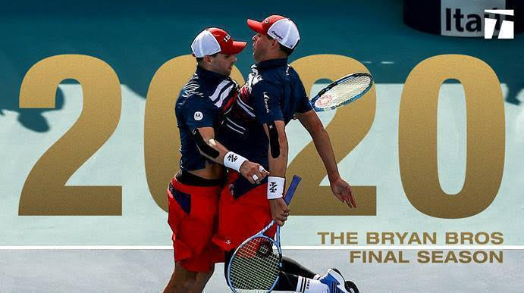

**Bryan Brothers To Retire After 2020 Season**

***American twins to finish career at US Open***

**On Wednesday, the most successful doubles team in tennis history, and two of the most decorated American players ever, made a joint statement on Tennis Channel: 2020 will be their final year on tour.**

**Mike**[**Bryan**](https://www.tennis.com/player/424/bob-bryan/)**told Tennis Magazine in 2016, when asked about his brother and fellow doubles star, Bob.  “We’ll go out together, we’ve got a special bond.  We've decided that 2020, at the US Open, we're going to shut it down.”**

**"One more season—and we're excited for it."**

**When a player announces an impending or immediate retirement, that player is typically well past their prime years and the message is a formality.  That couldn’t be further from the**[**Bryan**](https://www.tennis.com/player/413/mike-bryan/)**s’ situation.  The 41-year-old identical twins reached three finals in 2019 and won the prestigious Miami Open, along with Delray Beach.  As recently as July, Mike was ranked No. 1 in the ATP doubles rankings and as a team they were ranked #1, 2 or 3 for most of the year.**

**“Mike and I chose to finish our 2019 season after the**[**US Open**](https://www.atptour.com/en/tournaments/us-open/560/overview)**, even knowing there was a strong chance we’d qualify for the ATP Finals,” said**[**Bob Bryan**](https://www.atptour.com/en/players/bob-bryan/b588/overview)**. “After much discussion, we decided that it would be best to rest our minds and strengthen our bodies in preparation for 2020 which will be our final season on the ATP Tour.”**

**The US Open was also the tournament where the Bryans began their career, all the way back in 1995.  In the 24 years since, they’ve**[**set every significant doubles record**](http://tnns.co/WjQw5V)**, often obliterating previous marks. As the most accomplished team in doubles history, they have established standards of longevity and success that may never be matched again.**

**As a team, Bob and Mike have not finished outside of the year-end Top 10 since 2000.  They’ve won a record 16 Grand Slam doubles titles together, and over 1,100 matches, with a career winning percentage exceeding 75 percent.   The Bryan brothers have captured an Open Era record 118 trophies, including each of the four Grand Slams at least twice, all nine ATP Masters 1000s,**[**ATP Finals**](https://www.atptour.com/en/tournaments/nitto-atp-finals/605/overview)**(four titles) and the Olympic gold medal.**

**"Obviously, a very difficult decision, big decision—we've been on tour for 21 years, more than half our lives," said Bob. "Tennis is in our blood, so it feels like a part of us is dying."**

**“For the last 21 years, we have been so grateful for the opportunity to live out our dreams of playing professional tennis.  It has truly been a magical ride.  However, we want to end this great ride while we’re healthy and we can still compete for titles.”**

[**Mike Bryan**](https://www.atptour.com/en/players/mike-bryan/b589/overview)**said: “We are currently extremely motivated and excited going into our last season.  We will enjoy and appreciate each moment we have while saying our goodbyes and giving thanks to the fans who have given us so much joy.”**

**A testament to their popularity, from 2005 to 2017, the Bryans were presented the ATP Tour Fans' Favorite Team award each year.**

**Bob and Mike have played for each other, of course, but also for their country when called upon.  In Davis Cup, the Bryans had a record setting 24 wins and they were undefeated for two seasons in helping the team reach the Finals in 2004 and winning the Championship in 2007.**

**After winning bronze for the red, white and blue at the 2008 Olympic Games in Beijing, the Bryans won gold in London at Wimbledon four years later.**

**“Winning the gold transcended tennis, Mike Bryan said.  “And becoming a part of a special club of gold-medal winners, it seemed like we got more recognition for that than winning Wimbledon or any other Slam.”**

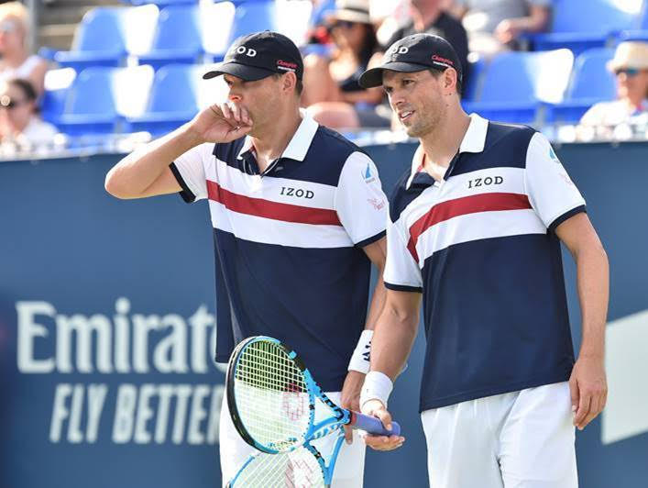

**The Bryans have been the standard bearers for doubles for more than 16 years, since they first ascended to #1 in the ATP Doubles Rankings on September 8th, 2003.  They spent 438 total weeks and ended 10 seasons as the #1 team - - - 2003, 2005, 2006, 2007, 2009, 2010, 2011, 2012, 2013 and 2014.  Mike, who became the oldest doubles #1 at age 40 on July 16th, 2018, has spent the most weeks at the summit of the team game (506). while Bob is second with 439 weeks at #1 and John McEnroe has 269.**

**Bringing their own energy and charisma to the court, they have endeared themselves to the public throughout the world, appearing in 177 tour-level finals and lifting tour-level trophies in 34 different cities.**

**As hard as the brothers have competed on the court, their off-court pursuits were met with equal passion.  They are accomplished musicians and their Bryan Bros. Band, featuring Counting Crows drummer Jim Bogios, plays several tennis and charity events each year.**

**They are charitable athletes, giving back to deserving children in Southern California and across the country with their Bryan Brothers Foundation.  The Bryan Brothers Foundation has made direct donations of $1.3 million to deserving kids and kids’ programs over the past decade.  Bob and Mike host two annual fundraisers in their hometown of Camarillo, California and West Palm Beach, Florida, where they partner with golf legend Jack Nicklaus to raise funds to positively impact the lives of children around the country.**

**During their career, the game of doubles has grown, and the Bryans have thrived along with it.  There’s no reason to believe that 2020 will be any different.**

***This piece is taken from excerpts of articles from the ATP, Tennis Channel, the NY Times, the LA Times, and the Wall Street Journal.***

**Video of the Bros. Making Their Retirement Announcement on Tennis Channel with Brett Haber and Jim Courier:**

[**https://www.tennis.com/pro-game/2019/11/bob-bryan-mike-bryan-brothers-2020-us-open/85950/**](https://www.tennis.com/pro-game/2019/11/bob-bryan-mike-bryan-brothers-2020-us-open/85950/)

**Please Kindly Vote Below for Your Favorite Singles Player and Your Favorite Doubles Team:**

**It is easy and just takes a few seconds and the deadline is close . . .**

**1.  You simply click on this hyper link:**[**https://www.atptour.com/en/news/atp-awards-2019-fans-favourite**](https://www.atptour.com/en/news/atp-awards-2019-fans-favourite)**and then scroll down just a little and you will see a small rectangular box with the heading: Vote for your Favorite Singles Player: . . .**

**2.  There will be a small blue arrow and you click on that and the Singles Players list will come down . . . Click on your favorite singles player . . . Then click the blue box that says *Vote* . . .**

**3.  Then Your Favorite Doubles Team will come on the screen and, again, click on the little blue arrow and the names of the various teams will come down . . . Pick your favorite team - - - hoping it is *Mike*and *Bob* - - - and then click *Vote.***

**Short Video Clip from the ATP on the Bryan Bros. Records:**

[**https://www.tennis.com/pro-game/2019/11/bryan-brothers-bob-mike-career-doubles-records/85931/**](https://www.tennis.com/pro-game/2019/11/bryan-brothers-bob-mike-career-doubles-records/85931/)