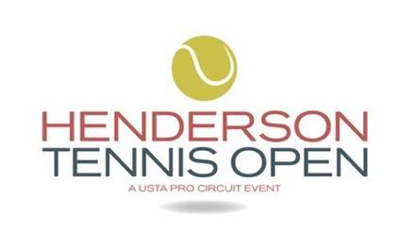

Unseeded Mayo Hibi Outlasts Anhelina Kalinina In Three Sets To Capture Henderson Tennis Open Singles Title

HENDERSON, Nev. (Nov. 10, 2019) – As a young child growing up in Southern California, Mayo Hibi perfected her backhand slice just like that of all-time great and Las Vegas resident Stephanie Graf.

Hibi used her precision shot-making and steady play to outlast fellow unseeded Anhelina Kalinina of Ukraine to capture the Henderson Tennis Open singles final on Sunday in two hours, 36 minutes, 6-2, 5-7, 6-2 in the USTA Women’s $60,000 Pro Circuit event that took place for the first year at the DragonRidge Country Club.

“My dad watched her play and modeled my game after her,” said Hibi, who won the 80 WTA ranking points and $9,142 despite losing her serve six times. It was the first $60,000-level event for the 23-year-old Hibi has won during her career and her ninth ITF singles title. She has won four at the $25,000 level and one $50,000 in Sacramento in 2013.

Irvine’s Hibi went up a set and 3-0 in the second set when she lost her focus, especially on her serve as she was broken four times by the 22-year-old Kalinina, a former Australian Open Junior Girls’ doubles champion. “It was really difficult,” Hibi said. “I lost the momentum and I really had to dig deep to fight back and gave it everything I had today. The last few years have been tough for me both physically and mentally and I haven’t had very strong results. I’m hoping to use this as a springboard for a better year next year.”

Kalinina reached a career-high No. 107 in the world a year ago and is currently ranked No. 181. She was also looking to win her first $60,000-level event. She has won eight ITF singles titles, including four at the $25,000 level and, like Hibi, one $50,000 in Sacramento back in 2015.

“I can’t be disappointed because I had a back injury and am just coming back,” Kalinina said in her on-court interview after the match. “Of course I would have wanted to win but getting to the final is a good week for me.”

Kalinina added: “I had a lot of support out there and I want to thank everyone for coming out this week.”

Kalinina received a runners-up check for $4,886 and 48 WTA points.

Both Hibi and Kalinina were headed to the Las Vegas Airport after the match to catch flights to Houston where they will play in the WTA 125K Oracle Open Challenger Series event in Houston the final tournament of the 2019 season.

Sponsors include: City of Henderson, USTA Nevada, Crovetti Orthopaedics, UMC, Marquis-Aurbach-Coffing, and Renewal by Andersen. The Official Charity is: Marty Hennessy Inspiring Children’s Foundation.

Follow along on Facebook: www.facebook.com/hendersontennisopen/; Instagram @hendersontennisopen and on Twitter @hendersonopen.

Steve Pratt | BZA PR
stevep@bzapr.com
310.408.4555

